To control the Bristol Wavelength Meter using LabVIEW to access the Bristol CLDevIface.dll, follow these steps:

- Add a Library Function Node to your .vi.

- Right click on this node to configure it.

- In this configure window click on Browse and find the path to the CLDevIface.dll which should be in the Bristol Wavelength Meter folder.

- Click the drop-down arrow next to Function Name to choose which function call you need. For this example we used the CLOpenUSBSerialDevice call, which should be the first function call in your .vi.

- Next you need to add what return type this function call is expecting. For the CLOpenUSBSerialDevice the return type is long. Refer to the cldevdll.h file for the return types and parameters for each function.

- If this function requires any input parameters, these need to be specified next by clicking Add Parameter After and the parameter will be added in the paranthesis.

- When finished the configuration window for the CLOpenUSBSerialDevice window should look like this: 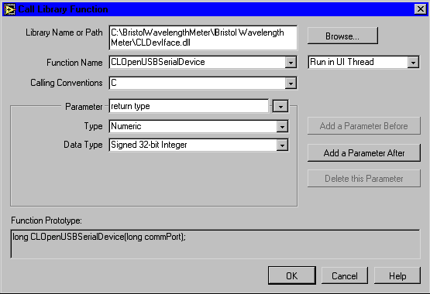

- Use these same steps to configure any other functions you might need and wire the nodes together. The example .vi shown opens up the serial device based on the com port specified and then gets the wavelength every time the user clicks on Get Wavelength.

- When the user is finished, the getWavelength_v80.vi closes the com port. Note that the getWavelength_v60.vi does not close the com port and is only included here for reference.

